Contents

Technical Appendix 2

Schematic diagram of the TV transmission model 2

Model description 3

Females 5

Males 9

Force of Infection 12

Progression Rate 15

Treatment Rate 16

HR HPV prevalence 18

Aging 18

Stratification of the population by vaccination status 19

Sensitivity analysis 21

Sensitivity of pap smear in TV detection 24

Omissions and Limitations 26

Partner Reinfection 26

Treatment failure 26

Background Screening 26

Diagnosis of those Actively Seeking Treatment 26

Asymptomatic Symptomatic 26

Gardasil Coverage Rate Projections 26

Partner notification 27

All new entries to the youngest age group are susceptible 27

Heterosexuality 27

Reference 28

# Technical Appendix

## Schematic diagram of the TV transmission model

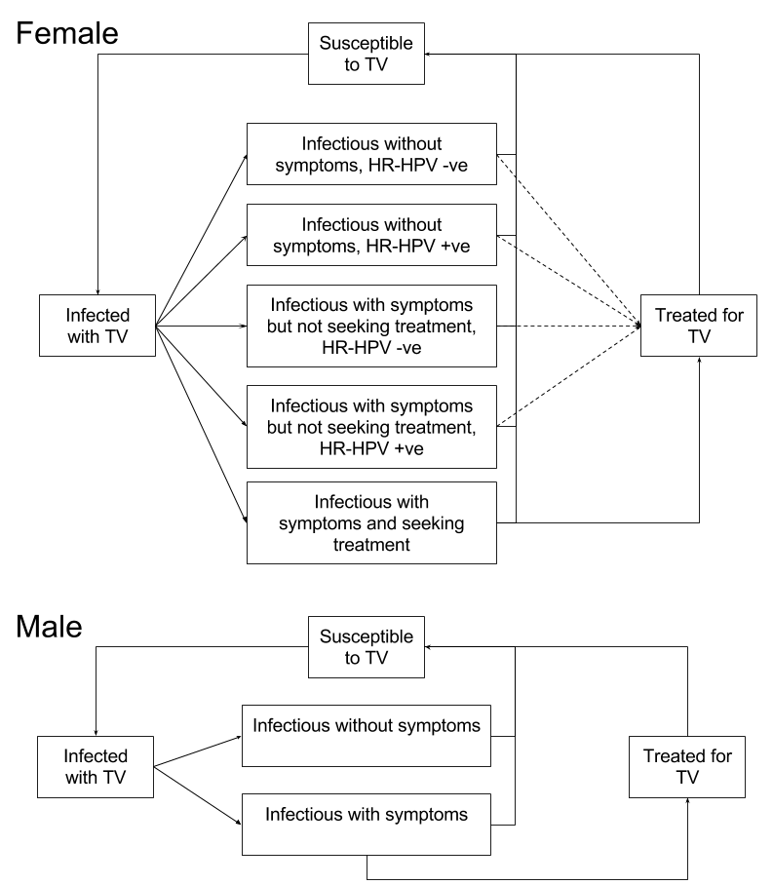

Figure A-: Schematic diagram of the TV transmission model. The arrows represent the population flow between compartments for females (top) and males (bottom) of a given age group. Stratification of the female population by HPV vaccination status is not shown in the diagram but the dashed lines for transition to the ‘Treated for TV’ compartment indicate that treatment rates vary by vaccination status

## Model description

We have developed a deterministic, compartmental model to describe the transmission of *Trichomonas vaginalis* (TV) in general population of Australia. The modelled population is divided into 21 compartments per age-group formulated as a system of ordinary differential equations (ODEs). The modelled population comprises males and females aged 16 to 59 years, stratified into 1-year age groups (i.e. 16-17, 17-18, … 59-60). Each ODE describes the change in the number of individuals in a particular compartment over time for a given set of parameter values.

Of the 21 compartments, vaccinated females account for 8, unvaccinated females 8, and males account for the remaining 5. The model is illustrated schematically in Figure A-2 and Figure A-3, which show the compartments and pathways between the compartments for females and males, respectively (both unvaccinated and vaccinated females are represented by the same compartmental diagram).

All compartments are mutually exclusive. A person cannot be in more than one compartment in a given time step. For a specific compartment, the rate at which people leave the compartment is given by 1 divided by the duration of time an individual spends in the compartment on average.

The compartments for females are:

S = Susceptibles to *Trichomonas vaginalis* (TV) infections

E = Exposed (infected but not yet infectious)

A- = Infected with TV, asymptomatic, tested negative for high-risk human papillomavirus types (HRHPV (-))

A+= Infected with TV, asymptomatic, tested positive for high-risk human papillomavirus types (HR HPV (+))

Y-= Infected with TV, symptomatic not seeking treatment, HR HPV (-)

Y+= Infected with TV, symptomatic not seeking treatment, HR HPV (+)

YT= Infected with TV, symptomatic seeking treatment

T = Treated

We assume that the rate at which females who are symptomatically infected with TV seek treatment is the same regardless of their HR HPV infection status, hence YT includes females who are HR HPV positive and HR HPV negative.

The compartments for males are:

S = Susceptibles to TV infections

E = Exposed (infected but not yet infectious)

A= Infected with TV, asymptomatic,

Y= Infected with TV, symptomatic

T = Treated

We assume that HR HPV prevalence in males will not influence the testing and treatment rate for TV in males as currently males are not screened for HR HPV.

In addition to the pathways shown in the Figures A-1 and A-2 below, further terms are included in each ODE in order to account for ageing (i.e., transition from one age group to the next). See the description under the heading “Aging” for more details.

### Females

#### Compartmental diagram

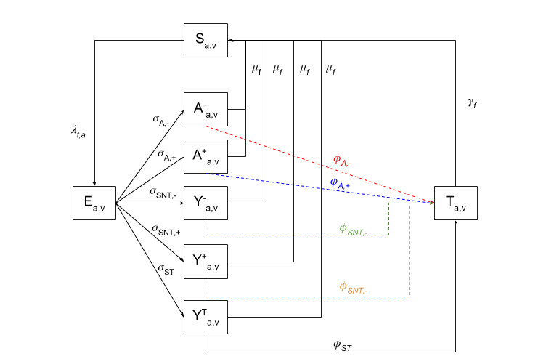

Figure A-: Compartmental diagram for all females in a given age-group and of the same vaccination status

For females in age-group *a* (with for age 16-17, for age 17-18 and so on) and vaccination status *v* (with *v* = 1 for vaccinated and *v* = 2 for unvaccinated), the corresponding ODEs are:

Table A-: Parameter table—Females

|  |  |  |  |  |
| --- | --- | --- | --- | --- |
|  | | | | |
| **Parameter** | **Description** | **Base Case** | **Range[1]** | **Source[2]** |
|  | Transmission probability per partnership  (male female) | 85% | 60 – 100% | 12 |
| **Parameter** | **Description** | **Value** | | |
|  | Force of infection (female) | See text under the heading “Force of Infection ” | | |
|  | | | | |
| **Parameter** | **Description** | **Base Case** | **Range** | **Source** |
|  | Mean duration of incubation period | 7 days | 3-28 days | 13-5 |
| PREVHR HPV, U | Prevalence of HR HPV, unvaccinated | 37.7% at t = 0 | *Assumption based on* 67 *, see text under HR HPV prevalence* | |
| PREVHR HPV,V | Prevalence of HR HPV, vaccinated | 22.8% at t = 0 |
|  | Probability of asymptomatic infection in female | 50% | 10 - 85% | 138-15 |
|  | Probability of a symptomatic infected female seeking treatment | 0.7 | 0.5 – 1 | *Assumption* |
| **Parameter** | **Description** | **Vaccination status** | **Formula** | **Value** |
|  | Daily progression rate (Asymptomatic, HR HPV -) | Unvaccinated |  | 0.0414 |
| Vaccinated |  | 0.0480 |
|  | Daily progression rate (Asymptomatic, HR HPV +) | Unvaccinated |  | 0.0301 |
| Vaccinated |  | 0.0234 |
|  | Daily progression rate  (Symptomatic not seeking treatment, HR HPV -) | Unvaccinated |  | 0.0124 |
| Vaccinated |  | 0.0144 |
|  | Daily progression rate  (Symptomatic not seeking treatment, HR HPV +) | Unvaccinated |  | 0.0090 |
| Vaccinated |  | 0.0070 |
|  | Daily progression rate  (Symptomatic seeking treatment) | Unvaccinated / Vaccinated |  | 0.0500 |
|  | | | | |
| **Parameter** | **Description** | **Base Case** | **Range** | **Source** |
|  | Estimated 2-yearly participation rate in routine cervical testing | 60% | 60% - 80% | 16 |
|  | Estimated 5-yearly participation rate in routine HPV testing | 80% | 80% - 100% | 17 |
|  | Sensitivity of detecting TV when actively seeking treatment (wet mount and culture)[3] | 70% | 36.4  – 98% | 381418-21 |
|  | Sensitivity of pap smear in TV detection | 57% | 18-83% | 821 |
|  | Average time from initial infection for TV symptoms to appear and TV treatment to be sought (for females with symptomatic TV infections who seek treatment) | 14 days | 0-14 days | 12 |
| **Parameter** | **Description** | **Model[4]** | **Formula** | **Value** |
|  | Daily probability of participating in cervical screening | Baseline |  | 0.0013 |
| New |  | 0.00088 |
|  | Daily probability of detecting TV through cervical screening | Baseline |  | 0.0005016 |
| New | 0.000741 |
|  | Daily treatment rate (Asymptomatic, HR HPV -) | Baseline |  | 0.000741 |
| New |  | 0 |
|  | Daily treatment rate (Asymptomatic, HR HPV +) | Baseline |  | 0.000741 |
| New |  | 0.0005016 |
|  | Daily treatment rate (Symptomatic, HR HPV -) | Baseline |  | 0.000741 |
| New |  | 0 |
|  | Daily treatment rate (Symptomatic, HR HPV +) | Baseline |  | 0.000741 |
| New |  | 0.0005016 |
|  | Daily treatment rate (Symptomatic, Seeks Treat) | Baseline / New |  | .05 |
|  | | | | |
| **Parameter** | **Description** | **Base Case** | **Range** | **Source** |
|  | Duration recommended to abstain from sexual intercourse after receiving treatment for TV[5] | 7 days | 7 – 14 days | *Assumption* |
|  | Average duration of untreated TV Infection | 3 years | 3 months -5 years | 1122223 |
| **Parameter** | **Description** | **Formula** | | **Value** |
|  | Daily rate of natural recovery |  | |  |
|  | Recovery rate after treatment |  | |  |

### Males

#### Compartmental diagram

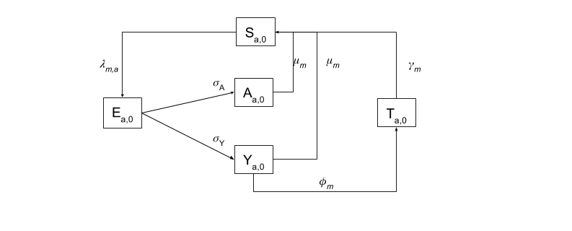

Figure A-: Compartmental diagram for males in a given age-group

For males in age-group *a* (with for age 16-17, for age 17-18 and so on) the corresponding ODEs are:

Table A-: Parameter table—Males

|  |  |  |  |  |
| --- | --- | --- | --- | --- |
|  | | | | |
| **Parameter** | **Description** | **Base Case** | **Range** | **Source** |
|  | Transmission probability per partnership (Female Male) | 70% | <70 – 80 % | 12 |
|  | Force of infection (male) | See text under the heading “Force of Infection ” | | |
|  | | | | |
| **Parameter** | **Description** | **Base Case** | **Range** | **Source** |
|  | Mean duration of incubation period | 10 days | 3 – 28 days | 13-514 |
|  | Probability of asymptomatic infection | 90% | 43%-98.5[6]% | 24[7],[8], 1425 |
| **Parameter** | **Description** | **Formula** | | **Value** |
|  | Daily progression rate(Asymptomatic) |  | | 0.0900 |
|  | Daily progression rate  (Symptomatic) |  | | 0.01 |
|  | | | | |
| **Parameter** | **Description** | **Base Case** | **Range** | **Source** |
|  | Sensitivity of TV infection testing | 91.7% | 56.0 – 100%[9] | 14 |
|  | Average time for TV symptoms to appear and TV treatment to be sought (for males with symptomatic TV infection who seek treatment) | 10 days | 0-10 days | 1426 |
|  | Probability of a symptomatic infected male seeking treatment | 0.6[10] | 0 - 1 | *Assumption due to lack of data* |
| **Parameter** | **Description** | **Formula** | | **Value** |
|  | Treatment rate |  | | 0.05502 |
|  | | | | |
| **Parameter** | **Description** | **Base Case** | **Range** | **Source** |
|  | Average duration of untreated infection | 4 months | <10 days – 4 months | 24[11],[12] 27[13],128 |
|  | Duration recommended to abstain from sexual intercourse after receiving treatment[14] | 7 days | 7 – 14 days | *Assumption due to lack of data* |
| **Parameter** | **Description** | **Formula** | | **Value** |
|  | Daily rate of natural recovery |  | | 0.0083 |
|  | Recovery rate after treatment |  | |  |

**Note**

The male pathway is independent of the cervical screening process as males do not participate in screening. Therefore, in this model only males with symptomatic TV infection who seek treatment are treated.

### Force of Infection

We define the mean annual partner change rate. We define this model without sexual activity stratifications. The reason for doing so is that trichomoniasis is not considered to require a core group (ie. high rate of sexual partner change per unit time) to sustain the infection 29. This is most likely due to the long duration of infection.

The model is stratified into 44 age-groups (age 16-17, age 17-18 … age 58-59). However for the purpose of force of infection calibration the age-groups are further aggregated into three major age-groups (16-19 years, 20-39 years, and 40-59 years). This is due to the lack of data to inform age-specific partner acquisition rates for each of the one year age-groups and the impracticality of handling large mixing matrices during model calibration. The model is calibrated using 3 age groups only (i.e. with 3 partner acquisition rates and a 3-by-3 mixing matrix), with the partner acquisition rate for each one year age group estimated by assuming uniform mixing within each major age-group. For example, if the partner acquisition rate for females aged 16-19 with males aged 16-19 is , then the partner acquisition rate for females aged 16-17 years with males aged 16-17 will be one quarter of the rate for the 16-19 age groups, or .

The mean annual partner change rate we use is derived from the following data (ASHR2) regarding mean number of lifetime partners 30:

Table A-: Mean number of lifetime partners (female) in ASHR2

|  |  |
| --- | --- |
| **Age group** | **Mean number of lifetime partners (female)** |
| 16-19 | 2.0 |
| 20-29 | 6.3 |
| 30-39 | 8.8 |
| 40-49 | 7.7 |
| 50-59 | 4.8 |

For each major age-group, we assumed that the lower limit of the range for the annual partner acquisition rate is the lower of the mean number of partners in the last year and the mean number of lifetime partners per year from age 16. The latter is calculated by dividing the mean number of lifetime partners gained by the range of the age-group. For example, given the mean number of lifetime partners of females in the 16-19 age-group is 2 then, on average, the minimum of number of partners per year for the oldest females in the age group (i.e. those aged 1 day before their 20th birthday) is . For the next age group 20-39, we assumed, at minimum, partners by age 40, so the rate is. For age group 40-59, we assume at least 4.8 partners by age 60, so the rate is .

The upper limit of the range for the annual partner acquisition rate for the 16-19 age-groups is based on the maximum number of lifetime partners a female can have on her 16th birthday (2.0). The upper linit of the range for the annual partner acquisition rate for 20-39 age-groups is based on the maximum number of lifetime partner a female can have by her 20th birthday , and the rate for the 40-59 age-groups is based on the maximum number of lifetime partner a female can have by her 40th birthday .

This produces the table below

|  |  |  |
| --- | --- | --- |
| ***Index (h)*** | **Age group** | **Range** |
| 1 | 16-19 | 0.50 – 2.00 |
| 2 | 20-39 | 0.36 – 1.57 |
| 3 | 40-59 | 0.11 – 0.32 |

We define to be the annual partner acquisition rate for a female within major age group *h,* as the total number of females in the population within major age group *h*, and as the total number of males in the population within major age group *i.* We also define as the probability of a female within major age group *h* forming a partnership with a male within major age group *i* (with ) . Therefore the total number of partnerships formed between the two gender-age groups in the population will be . [15]

Both and are calibrated such that the baseline model will maintain an endemic TV population prevalence of 0.4%. The age specific TV prevalence for the baseline model is shown in Figure A-4.



Figure A-: Age-specific TV prevalence for the baseline model

The results of the calibration are listed in the table below.

Table A-: Calibrated sexual behaviour parameters

|  |  |  |
| --- | --- | --- |
| **Parameter** | **Value** | **Range** |
|  |  | 0 -1 |
|  | 1.978 | 0.50 – 2.00 |
|  | 0.710 | 0.36 – 1.57 |
|  | 0.173 | 0.11 – 0.32 |

Using the parameter values above, the number of partnerships per year per female between females in major age-group *h* (i.e. row *h*) and males in major age-group *k* (i.e. column *k*) can be expressed as:

,

or in terms of age-groups used in the model (i.e. with 1-year age strata), this means the mixing between a female in age-group and male in age-group can be defined as:

‘

where if is in the 16-19 major age-group, if is in the 20-39 major age-group, and if is in the 40-59 major age-group. Similarly, if is in the 16-19 major age-group, if is in the 20-39 major age-group, and if is in the 40-59 major age-group.

Since the total number of partnerships within the population must be the same across respective gender-age groups (i.e. the total number of partners that females of age-group *i* have with males of age-group *j* must equal the total number of partners males of age-group *j* have with females of age-group *i*) , the following constraint applies for male of age group *j* and female of age group *i*:

.

The **force of infection** term is denoted by . The parameter represents the force of infection relevant for the compartment with gender *g* (where *m* =male and *f* = female) and age group *a*.

We define as the per-partnership probability of transmission. Moreover, instead of explicitly defining parameters for the following, they will be considered within the single composite parameter

* Sexual activity levels
* Condom usage
* Condom efficacy
* Number of acts per partnership

The force of infection for females of age-group *i* is defined as:

Similarly, the force of infection for males of age-group *j* can be defined as:

### Progression Rate

The mean duration of the Incubation stage for both genders is assumed to be 7 days 4. The rate of indivduals leaving the Exposed compartment in one iteration of the model must be equal to the inverse of the duration of the incubation stage.

So the General Progression Rate (GPR) is .

We assume that 75% of male infecteds and 50% of female infecteds are asymptomatic. Both proportions are difficult to estimate from the literature (particularly for females). The literature suggests that *most* male infections are asymptomatic. Figure A-5 below presents the different reported ranges for the proportion of female TV infections that are asymptomatic.

Figure A-: Proportion of female TV infection that are asymptomatic across multile studies

### Treatment Rate

Once infected, the rate at which an individual is treated will depend on which of the infected compartments they are in. As the individuals have already been triaged according to high risk HPV status, vaccination status will not influence these rates.

#### Baseline model

For the baseline model, we assumed pap smear as primary diagnostic test, testing coverage of 60% per 2 year.

With pap smears as the primary cervical cancer diagnostic measure, there is no impact of HPV positivity on TV detection, as HPV negative individuals infected with TV have an equal probability as HPV positive individuals of being detected through cervical screening HPV vaccination status is therefore irrelevant in this case.

Currently, there is a 60% biennial participation rate in cervical screening 16**.** We can think of this as the probability that an individual will participate in routine cervical screening every 2 years (at least once). The daily rate of screening is calculated using the following method[16]:

During routine cervical screening, TV can be detected through cytology. The sensitivity of cytology for TV detection is 57%821. Therefore the daily rate of TV detection through cervical screening is given by:

If an individual is symptomatic then TV may be detected through the biennial cervical screening process (as detailed above) OR they may actively seek treatment. For those symptomatic individuals seeking treatment, we assume diagnostics will be carried out using wet mount, which has sensitivity for TV detection of 60% 3818-20.

#### New screening program model

For the modelling of the revised cervical screening program, we assumed an HPV DNA test will replace the pap smear as the primary diagnostic test, and 5-yearly testing coverage of 80% based on current 5-yearly participation in the cervical screening program.

The target population will be invited to undergo a HPV test every 5 years with the participation rate forecast to be 80% 17. We can think of this as the probability that an individual will participate (at least once) in routine cervical screening every 5 years. The daily probability that an individual will be screened is calculated using the following method[17]:

If an infected individual undergoes a HPV test and is HR HPV positive, they will progress to LBC. LBC sensitivity is 57% 821, meaning that 57% of the time, TV will be successfully detected in an infected individual. The daily probability of TV detection through cervical screening is given by:

If an individual infected with HR HPV has symptomatic TV then this may be detected through the 5 yearly cervical cancer screening process OR they may actively seek treatment based on their symptoms. We assume that if a symptomatic infected individual seeks treatment then they will undergo a wet mount test (as opposed to a pap smear, PCR, culture). For those symptomatically infected individuals that seek treatment, 60% will have TV successfully detected. This is based on sensitivity for TV detection of 60% 3818-20.

If the infected individual is HR HPV negative, they will not progress to LBC and hence TV will not be detected and treated. Hence .

### HR HPV prevalence

In 2012 and 2014, Australian studies revealed that in a sample of vaccinated females aged 18-24, the prevalence of HR HPV was 32.8%-34% 67. In unvaccinated females aged 18-24, HR HPV prevalence was found to be 42.1%-44%. It was stated that “any impact measured in this age group would most closely approximate the benefit that might be expected for future cohorts of adolescents”. To be conservative, we use the lower bound for prevalence as our base case.

Tabrizi et al 2012 6 compared the HR HPV prevalence from 2005-2007 to 2010-2011 period. We assume that at the time of commencement of the revised cervical screening program (end of 2016), HR HPV prevalence will continue to decline at the same rate as reported by Tabrizi et al 2012, i.e., from 47.0% to 42.1% in the unvaccinated population over 5 years, and from 47.0% to 32.8% in the vaccinated population over 5 years. This can be express as follows:

Hence

where is the time elapsed from the commencement of the vaccination program, and is the HPV prevalence before vaccination, taken to be 47.0% based on HPV prevalence in 2007-2009. Note that in the model, we assume that the vaccination program has already been in place for 10 year at , so

As comparison, a recent study has found that 80% girls-only vaccine coverage can lead to close to 0.9 relative reduction in HPV-16 prevalence over 70 years. 31 In our estimation, the relative reduction in HR HPV over 70 years is approximately 0.8 for unvaccinated female and close 1 for vaccinated female.

### Aging

Aging is included in the model as an additional term in the ODEs. The size of the term is based the size of the compartment as well as the span of the age group. For example, if the age stratum spans 20 years, then one-twentieth of each compartment will move to a compartment of the same disease state but at the next (older) age stratum each year (apart from the oldest age group, in which case one-twentieth of all compartments will be removed from the population, while the same number of individuals will be added to the susceptible compartment in the youngest age group, with 80% of females vaccinated).

We assume that the total population size remains constant over time, i.e., the number of people leaving the oldest age group per unit time equals the number of people entering the youngest age group in the same time interval. We also ignore deaths as these are unlikely to occur as a consequence of TV infection.

Therefore aging is captured in the model as follows:

with

and is the compartment of age group and vaccinate status

### Stratification of the population by vaccination status

The initial conditions of the model specify the fraction of the population that is vaccinated based on current vaccination coverage in Australia. When running the model, the proportion of women in the population that is vaccinated will increase over time with ongoing vaccination. The proportions of females vaccinated for selected age-groups over 100 years are shown in Figure A-6.



Figure A-: Proportion of female vaccinated introduced in the model

## Sensitivity analysis

SaSAT software was used to generate 5,000 parameter sets with Latin hypercube sampling,32 where model parameters were randomly sampled from uniform distributions with ranges as specified in this appendix. The model was then run to equilibrium for all 5,000 parameter sets under baseline model conditions (i.e. 60% of women age 18 or older undergo cytology screening every 2 years), and the 50 sets yielding equilibrium prevalence closest to 0.4% were selected for evaluating screening scenarios and sensitivity analysis.

In Figure A-6 Tornado plots are given showing the partial rank correlation coefficients (PRCC) for all model parameters, where the measured outcome is the absolute difference in TV prevalence 20 years after all the key changes to cervical screening have been implemented (i.e. scenario 3 in the main text). In both cases the sensitivity of the pap test (“Sen_Pap” in the figure) is ranked highest, with PRCC = 0.65 if HR HPV prevalence is fixed, and PRCC = 0.67 if HR HRV continues to decline.

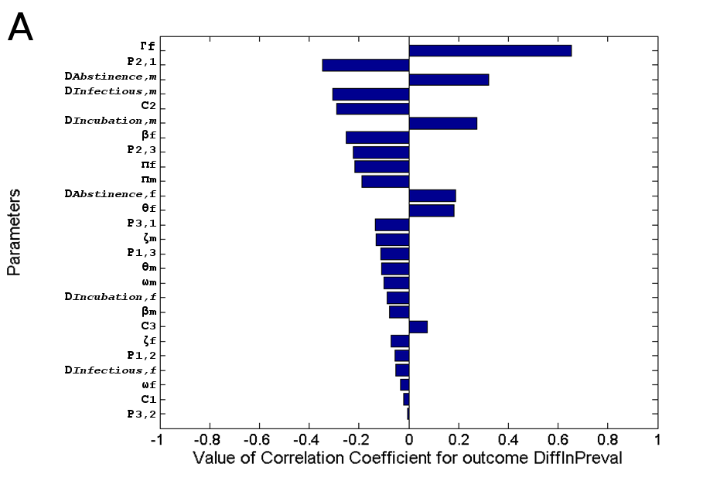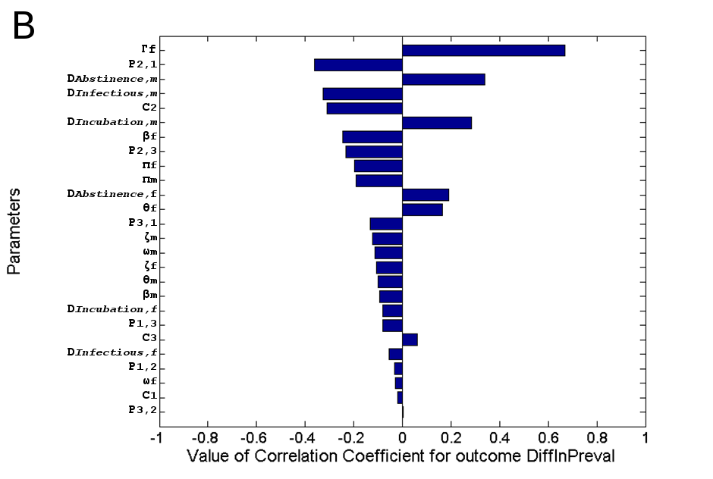

Figure A-: Correlation coefficients for all model parameters, where the measured outcome is the difference in TV prevalence, from baseline, 20 years after all the key changes to cervical screening have been implemented. A: HR HPV prevalence fixed to the estimated 2016 level; B: HR HPV prevalence continues to decline at the estimated pre-2016.

The PRCC each model parameters are listed in the table below.

Table A-: PRCC of model parameters

|  |  |  |
| --- | --- | --- |
| Parameters | PRCC | |
| HR HPV prevalence is fixed | HR HPV prevalence continues to decline |
|  | -0.05574 | -0.0307 |
|  | -0.11351 | -0.07969 |
|  | -0.34681 | -0.36335 |
|  | -0.22259 | -0.23371 |
|  | -0.13421 | -0.13217 |
|  | -0.00319 | 0.004231 |
|  | -0.01966 | -0.018 |
|  | -0.29012 | -0.31136 |
|  | 0.072878 | 0.062005 |
|  | -0.25058 | -0.24555 |
|  | -0.07766 | -0.095 |
|  | 0.272612 | 0.284409 |
|  | -0.08718 | -0.07973 |
|  | -0.1323 | -0.12132 |
|  | -0.06991 | -0.10579 |
|  | -0.10908 | -0.10023 |
|  | 0.181651 | 0.165278 |
|  | -0.10109 | -0.11346 |
|  | -0.03449 | -0.0304 |
|  | -0.1876 | -0.19205 |
|  | -0.21707 | -0.19855 |
|  | 0.652413 | 0.667776 |
|  | -0.30624 | -0.32753 |
|  | -0.05305 | -0.05509 |
|  | 0.319998 | 0.340245 |
|  | 0.187197 | 0.190808 |

## Sensitivity of pap smear in TV detection

In our baseline model, we assume the sensitivity of the pap smear for TV detection is 57%. In practice, however, the sensitivity may vary from less than 20% to more than 80%.821 This uncertainty will have some impact on our results, as the baseline model is calibrated such that the TV prevalence at equilibrium is 0.4% before switching from cytology-based screening to HPV testing. For example, if pap smear sensitivity is assumed to be much lower than 57% in the baseline model (hence less TV is detected on pap smears), and assuming the transmissibility and duration of TV is fixed, then the sexual behaviour in the model must be adjusted to maintain the same equilibrium prevalence at 0.4%.

For the results in Table A-6, we recalibrated the model by adjusting the contact rates (i.e. and the degree of mixing (i.e. ), and selected a single parameter set that produce a TV equilibrium prevalence of 0.4% while the sensitivity of the pap smear for TV detection is set to either 30% or 70%. We then estimated the absolute and relative increases in TV prevalence over time for scenario 3 (the full complement of changes to the cervical screening programme are implemented – see main text) under these altered assumptions. The values obtained for parameters varied in the calibration process are listed in Table A-7.

Table A-: Absolute and relative increases in TV prevalence from baseline at t = 5, 10, 15, and 20 years for scenarios 3 (i.e. the full complement of changes to the cervical screening programme are implemented), while assuming the sensitivity of the pap smear for TV detection is either 30% or 70%.

|  |  |  |  |  |  |  |  |  |
| --- | --- | --- | --- | --- | --- | --- | --- | --- |
| **Absolute increase in TV prevalence from t = 0 (%)** | | | | | | | | |
| **Sensitivity of pap smear** | **30%** | | | | **70%** | | | |
| Years after changes to cervical screening program | 5 | 10 | 15 | 20 | 5 | 10 | 15 | 20 |
| HR HPV prevalence fixed | 0.14 | 0.37 | 0.68 | 1.02 | 0.49 | 1.51 | 2.98 | 4.38 |
| HR HPV prevalence continues to decrease at current rate | 0.14 | 0.38 | 0.70 | 1.09 | 0.49 | 1.56 | 3.14 | 4.68 |
| **Relative increase in TV prevalence from t = 0 (%)** | | | | | | | | |
| **Sensitivity of pap smear** | **30%** | | | | **70%** | | | |
| Years after changes to cervical screening program | 5 | 10 | 15 | 20 | 5 | 10 | 15 | 20 |
| HR HPV prevalence fixed | 1.3 | 1.9 | 2.7 | 3.6 | 2.2 | 4.8 | 8.5 | 11.0 |
| HR HPV prevalence continues to decrease at current rate | 1.3 | 2.0 | 2.8 | 3.7 | 2.2 | 4.9 | 8.9 | 12.7 |

Table A-: Calibrated sexual behaviour parameters while assuming the sensitivity of the pap smear for TV detection is either 30% or 70%.

|  |  |  |  |  |
| --- | --- | --- | --- | --- |
| **Calibrated parameter value** | | | | |
| **Sensitivity of pap smear** | **57% (baseline)** | **30%** | **70%** | **Range** |
|  | 0.0229 | 0.0470 | 0.0129 | 0.00 – 1.00 |
|  | 0.0234 | 0.0461 | 0.0133 | 0.00 – 1.00 |
|  | 0.9791 | 0.9443 | 0.9880 | 0.00 – 1.00 |
|  | 0.0003 | 0.0032 | 0.0001 | 0.00 – 1.00 |
|  | 0.0108 | 0.0086 | 0.0109 | 0.00 – 1.00 |
|  | 0.0818 | 0.0818 | 0.0818 | 0.00 – 1.00 |
|  | 1.978 | 1.975 | 1.988 | 0.50 – 2.00 |
|  | 0.710 | 0.658 | 0.733 | 0.36 – 1.57 |
|  | 0.173 | 0.173 | 0.173 | 0.11 – 0.32 |

# Omissions and Limitations

### Partner Reinfection

Unfortunately, partner reinfection from current partners cannot be represented in a standard compartmental model. Ideally, a model representing the prevalence of trichomoniasis would include partner reinfection as it is a common reason that Treated individuals will persist in presenting positive. We have no reason to believe trichomoniasis recovery confers the individual any level of immunity 2833.

### Treatment failure

The assumption that treatment is 100% effective is reasonable because the current STI guidelines detail that clinicians should see the patient for a follow up appointment in 7 days to ensure that treatment has indeed been effective. In the case that Metronidazole treatment has failed (max 10%1219), an alternative treatment plan will be implemented. The time delay until effective treatment is administered will be minimal.

### Background Screening

Firstly, it is important to note that trichomoniasis is not currently a STI that is included in background sexual health checks. If tests all the routinely tested STIs (primarily gonorrhoea and chlamydia) return negative results *and* the infected individual is experiencing symptoms then a trichomoniasis test may be conducted. In urban Australia, where trichomoniasis prevalence is so low 91834, only a very small number of people will have TV infection discovered in this manner. Excluding background screening is justifiable for two reasons. Firstly, no studies have detailed how many trichomoniasis cases are picked up through background screening[18] . Secondly, even if there were available data, it would be such a small figure that its inclusion would have little impact on the model outcomes.

The reasons we chose not to incorporate the below into the model include: little impact on the dynamics of the model, paucity of data on the epidemiology of trichomoniasis and inability to include within a compartmental model.

### Diagnosis of those Actively Seeking Treatment

For symptomatic individuals that seek treatment, we assume that treatment will be in the form of a culture test or a wet mount test. Such an assumption stems from common clinician practice. It must be noted, though, that it is in contradiction with the Australian National Management Guidelines for STIs, which recommend a Nucleic Acid Amplification Test, which has sensitivity close to 100%. We do not account for the percentage that get tested through wet mount and those through culture – instead, a range is given that includes both methods.

### Asymptomatic Symptomatic

We ignore the possibility that asymptomatic cases could become symptomatic and visa versa. Other authors2833 have found that “allowing for symptomatic infections to become asymptotic does not improve the model fit to the observed STI prevalence data” (Johnson, et all.). Furthermore, there is no evidence of symptomatic cases developing into asymptomatic infections. It has been reported that a third of asymptomatic women become symptomatic after 6 months 26.

### Gardasil Coverage Rate Projections

We assume that the coverage rate will eventually grow until it reaches 80% where it will then plateau. The 80% is based on the vaccination coverage of females of age 15 according to the 2015 HPV register (84% for 2-dose, 78% for 3-dose) 35, however this plateau rate is likely to be higher when the 9-valent vaccine, a 2-dose regimen, become available in Australia. On top of that, a recent study suggested that the vaccination coverage based on the register is likely an underestimate of vaccine coverage in the population. 36

### Partner notification

Our model does not account for the possibility of asymptomatically infected individuals being treated. This circumstance would arise if a partner has been diagnosed with trichomoniasis and as a result the individual seeks screening and, if necessary, treatment. If we did consider this outcome then we would apply the same assumption as we did for symptomatically infected individuals seeking treatment: diagnosis may only occur through wet mount or culture.

### All new entries to the youngest age group are susceptible

We assume all people entering the model population are susceptible to TV (i.e., not infected).

### Heterosexuality

Bisexuality or homosexuality are not accounted for in this model for trichomoniasis. If necessary, this should be relatively easy to incorporate at a later date.

# Reference

1. ASHM. Trichomoniasis [Available from: <http://contacttracing.ashm.org.au/conditions/when-contact-tracing-is-recommended/trichomoniasis> accessed 11 Oct 2016.

2. Ali IS, Klassen-Fischer MK. Trichomoniasis. In: Meyers WM, Firpo A, Wear DJ, eds. Topics on the Pathology of Protozoan and Invasive Arthropod Diseases: ARMED FORCES INST OF PATHOLOGY WASHINGTON DC 2011.

3. Meites E. Trichomoniasis: the "neglected" sexually transmitted disease. *Infect Dis Clin North Am* 2013;27(4):755-64.

4. Webber R. Communicable Disease Epidemiology and Control: A Global Perspective. 3rd ed: Cabi 2009.

5. Cudmore SL, Delgaty KL, Hayward-McClelland SF, et al. Treatment of infections caused by metronidazole-resistant Trichomonas vaginalis. *Clinical microbiology reviews* 2004;17(4):783-93, table of contents. doi: 10.1128/CMR.17.4.783-793.2004

6. Tabrizi SN, Brotherton JM, Kaldor JM, et al. Fall in human papillomavirus prevalence following a national vaccination program. *J Infect Dis* 2012;206(11):1645-51. doi: 10.1093/infdis/jis590

7. Tabrizi SN, Brotherton JML, Kaldor JM, et al. Assessment of herd immunity and cross-protection after a human papillomavirus vaccination programme in Australia: a repeat cross-sectional study. *Lancet Infect Dis* 2014;14(10):958-66.

8. Lusk MJ, Naing Z, Rayner B, et al. Trichomonas vaginalis: underdiagnosis in urban Australia could facilitate re-emergence. *Sexually Transmitted Infections* 2010;86:227-30.

9. Uddin RNN, Ryder N, McNulty AM, et al. Trichomonas vaginalis infection among women in a low prevalence setting. *Sexual health* 2011;8(1):65-8.

10. Sutton M, Sternberg M, Koumans EH, et al. The prevalence of Trichomonas vaginalis infection among reproductive-age women in the United States, 2001-2004. *Clin Infect Dis* 2007;45(10):1319-26.

11. Chapwanya A, Usman AY, Irons PC. Comparative aspects of immunity and vaccination in human and bovine trichomoniasis: a review. *Trop Anim Health Prod* 2016;48(1):1-7. doi: 10.1007/s11250-015-0909-1

12. Van Der Pol B, Williams JA, Orr DP, et al. Prevalence, incidence, natural history, and response to treatment of Trichomonas vaginalis infection among adolescent women. *J Infect Dis* 2005;192(12):2039-44.

13. Bowden FJ, Paterson BA, Mein J, et al. Estimating the prevalence of Trichomonas vaginalis, Chlamydia trachomatis, Neisseria gonorrhoeae, and human papillomavirus infection in indigenous women in northern Australia. *Sexually Transmitted Infections* 1999;75(6):431-34.

14. Poole DN, Scott McClelland R. Global epidemiology of Trichomonas vaginalis. *Sex Transm Infect* 2013 doi: sextrans-2013-051075 [pii]

10.1136/sextrans-2013-051075 [published Online First: 2013/06/08]

15. PHAC (Public Health Agency of Canada). Trichomonas vaginalis [Available from: <http://www.phac-aspc.gc.ca/lab-bio/res/psds-ftss/trichomonas-eng.php> accessed 12 Oct 2016.

16. AIHW. Cervical screening in Australia 2013–2014. Cancer series no 97. Canberra: AIHW, 2016.

17. Field T. HPV Testing - Warts ‘n’ All. [Available from: <http://www.nrl.gov.au/CA25782200833499/All/1FC618DDA51A69F8CA257D1E00837B74/$file/P3_Tony%20Field.pdf>.

18. Kwon I, McNulty A, Read P. The prevalence of Trichomonas vaginalis detected by wet mount and polymerase chain reaction in Sydney women. *Sexual health* 2013;10(4):385-6.

19. Kissinger P. Trichomonas vaginalis: a review of epidemiologic, clinical and treatment issues. *BMC infectious diseases* 2015;15:307.

20. Alcaide ML, Feaster DJ, Duan R, et al. The incidence of Trichomonas vaginalis infection in women attending nine sexually transmitted diseases clinics in the USA. *Sexually transmitted infections* 2016;92(1):58-62.

21. White RG, Orroth KK, Korenromp EL, et al. Can population differences explain the contrasting results of the Mwanza, Rakai, and Masaka HIV/sexually transmitted disease intervention trials?: A modeling study. *J Acquir Immune Defic Syndr* 2004;37(4):1500-13.

22. Bowden FJ, Garnett GP. Trichomonas vaginalis epidemiology: parameterising and analysing a model of treatment interventions. *Sexually Transmitted Infections* 2000;76(4):248-56.

23. World Health Organization Department of Reproductive Health and Research. Prevalence and incidence of selected sexually transmitted infections, 2011.

24. Krieger JN, Verdon M, Siegel N, et al. Natural history of urogenital trichomoniasis in men. *J Urol* 1993;149(6):1455-8.

25. Sena AC, Miller WC, Hobbs MM, et al. Trichomonas vaginalis infection in male sexual partners: implications for diagnosis, treatment, and prevention. *Clin Infect Dis* 2007;44(1):13-22.

26. Petrin D, Delgaty K, Bhatt R, et al. Clinical and microbiological aspects of Trichomonas vaginalis. *Clinical microbiology reviews* 1998;11(2):300-17.

27. Weston TE, Nicol CS. Natural History of Trichomonal Infection in Males. *Br J Vener Dis* 1963;39:251-7.

28. Heine P, McGregor JA. Trichomonas vaginalis: a reemerging pathogen. *Clinical obstetrics and gynecology* 1993;36(1):137-44.

29. Bowden FJ, Garnett GP. Why is Trichomonas vaginalis ignored? *Sexually Transmitted Infections* 1999;75(6):372-73.

30. Rissel C, Badcock PB, Smith AMA, et al. Heterosexual experience and recent heterosexual encounters among Australian adults: the Second Australian Study of Health and Relationships. *Sexual health* 2014;11(5):416-26.

31. Brisson M, Bénard É, Drolet M, et al. Population-level impact, herd immunity, and elimination after human papillomavirus vaccination: a systematic review and meta-analysis of predictions from transmission-dynamic models. *The Lancet Public Health* 2016;1(1):e8-e17. doi: <http://doi.org/10.1016/S2468-2667(16)30001-9>

32. Hoare A, Regan D, Wilson DP. Sampling and sensitivity analyses tools (SaSAT) for computational modelling. *Theoretical Biology and Medical Modelling* 2008;5(4)

33. Johnson LF, Dorrington RE, Bradshaw D. The role of immunity in the epidemiology of gonorrhoea, chlamydial infection and trichomoniasis: insights from a mathematical model. *Epidemiology and infection* 2011;139(12):1875-83.

34. Bygott JM, Robson JM. The rarity of Trichomonas vaginalis in urban Australia. *Sex Transm Infect* 2013;89(6):509-13. doi: 10.1136/sextrans-2012-050826

35. National HPV Vaccination Program Register. HPV vaccination coverage by dose number (Australia) for females by age group in mid 2015 2015 [Available from: <http://www.hpvregister.org.au/research/coverage-data/HPV-vaccination-coverage-by-dose-2015> accessed 25 Nov 2016.

36. Brotherton JM, Liu B, Donovan B, et al. Human papillomavirus (HPV) vaccination coverage in young Australian women is higher than previously estimated: independent estimates from a nationally representative mobile phone survey. *Vaccine* 2014;32(5):592-7. doi: 10.1016/j.vaccine.2013.11.075

1. For parameters that are a combination of other (previously defined) parameters, the range is omitted due to the large variability that results from all contributing parameters being uncertain. For description of the variability of each contributing parameter, please see their individual respective ranges.
2. Where ‘*Assumption’* is specified as a source, there was no available data in the literature to inform the parameter base case point estimate or range.
3. See “Diagnosis of those Actively Seeking Treatment” under “Omissions and Limitations”
4. Baseline = Pap smear as primary diagnostic test, testing coverage of 60% per 2 year, New = HPV test as primary diagnostic test, testing coverage of 80% per 5 year
5. While abstaining from sex, the individual is no longer considered to be infectious.
6. Among a probability sample of young adults (N = 2,936) in Baltimore, Maryland — an urban area with high rates of reported STIs
7. Before treatment or spontaneous resolution, 12 out of 21 men with trichomoniasis showed at least 2 out of three of the following symptoms: symptomatic urethral discharge, urethral discharge on physical examination or at least 5 polymorphoneuclear leukocytes per oil immersion
8. Selection bias may be apparent – they are men attending a sexual health clinic and therefore are more likely to be symptomatic.
9. Culture is considered to be the least sensitive test for TV. While it is unlikely that a male will be tested for trichomoniasis in an urban area in Australia, currently urine PCRs are used in remote Australian communities where prevalence is much higher.
10. We assumed a 70% probability that a female with symptoms will actively seek treatment. We could not find any literature to inform the value for this parameter. We assume also that the probability is lower for males, based on the assumption that symptomatic males are less likely to seek treatment.
11. 1 asymptomatic man out of an initial 50. Abstained from sex during the research period.
12. Within 2 weeks, 36% untreated men tested negative for trichomoniasis
13. Within 2 weeks, 59% untreated men tested negative for trichomoniasis
14. While abstaining from sex, the individual is no longer considered to be infectious.
15. In this appendix, and are defined from the female perspective. But it is also possible to define and from male perspective, and determine acquisition rate by using the relation
16. Above, we converted proportions to rates using the following formula: ⬄
17. Above, we converted proportions to rates using the following formula: ⬄
18. A consequence of such low prevalence.