Supplementary table 1. HPV type attribution in relation to cervical (pre) cancer

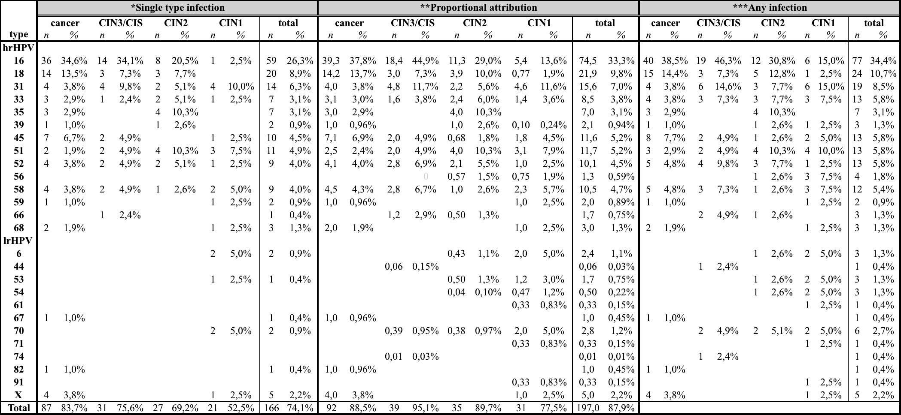

* ”Single type infection” is calculated by the frequency of each HPV genotype.
** ”Proportional attribution” of a specific HPV genotype in a multiple infection is assessed according to the frequency of that genotype at the respective disease category. (Wentzensen et al. 2010)
*** In ”any infection attribution” each infection is accounted fully to the lesion. (Wentzensen et al. 2010)

